Project Status Report

虚拟电子学校

V 1.0

Erin Wang
Project Manager



Sep 29, 2001

Document Control

Change Record

Date | Author | Version | Change Reference
9/29/2000 | Erin Wang | V1.0

Reviewers

Date | Name | Position

Approved By

Name | Position | Signature | Date
The copy numbers referenced above should be written into the Copy Number space on the cover of each distributed copy. If the document is not controlled, you can delete this table and the Copy Number label from the cover page.

CONTENTS

1. Customer Complains 4
2. Milestones/Tasks Achieved 4
3. Milestones/Tasks Planned for next period 4
4. Quality Assurance Activities 4
5. Issues 4
6. Number of Requirement Change Request 4
7. Major Changes from the Plan 5

Customer Complains
No teacher monitor showing system.

Milestones/Tasks Achieved
Milestones/Tasks | Status | Remark | Deliverables | Delay
Software Detail Design | Complete |  | Detail Design Document  JSP Architecture Design | 0days

Milestones/Tasks Planned for next period
Time: Sep 28-Oct 30
Milestone: Coding and Unit Test
Deliverables:
- Coding
- System Test Plan

Quality Assurance Activities
QA Activity | Defects detected | Defects closed | Defects open
Detail Design Document | 33 | 33 | 0

Issues
No. | Issue | Raised by | Action by | Status
1 | Need High Level Design guideline and example | Erin |  | Open
2 | Need High Detail Design guideline and example | John |  | Open
3 | Need unit Test plan template | Erin | John | Open
4

Number of Requirement Change Request

Major Changes from the Plan

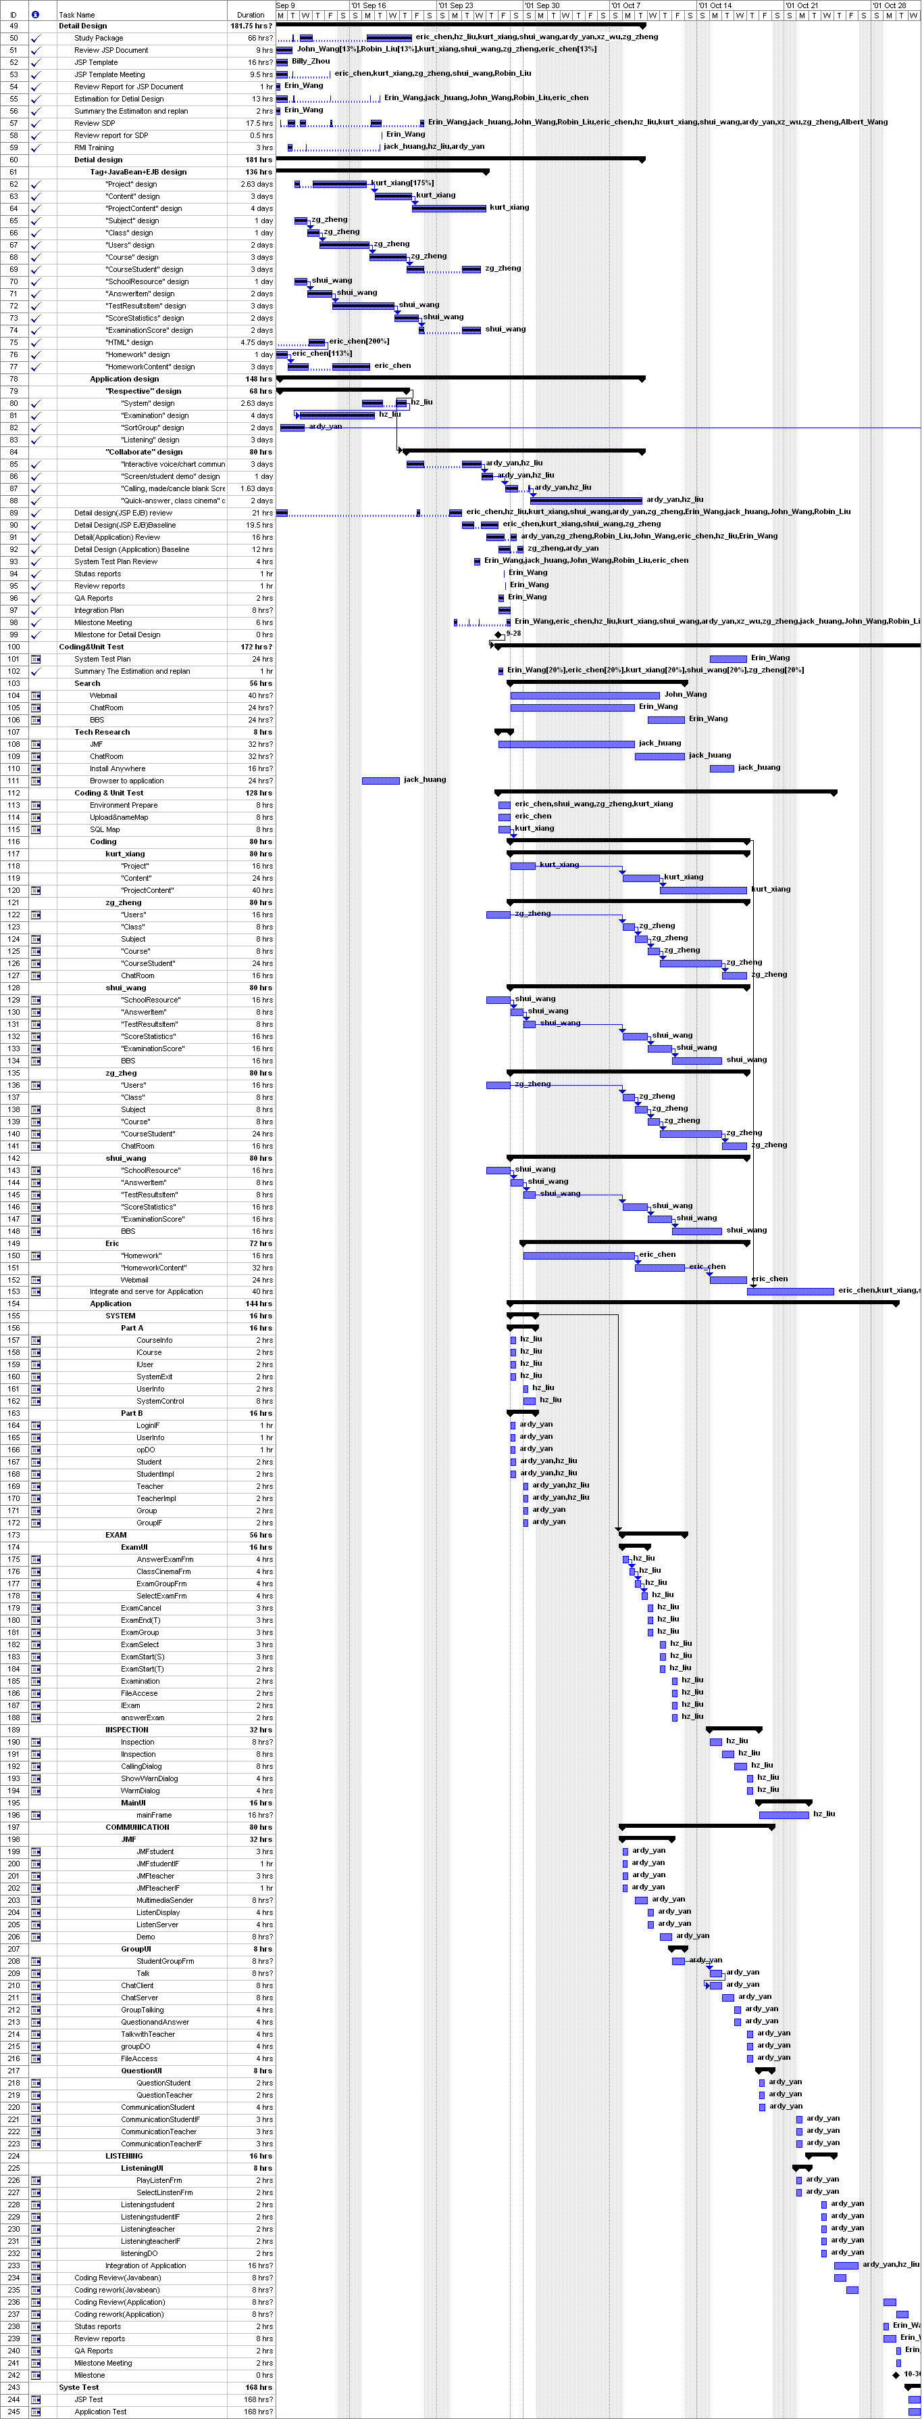

Standard Tailoring Record

Delete Item:
Item Name | Reason
Add Item:
Item Name | Reason
Modify Item:
Item Name | Reason | Modification

